MATH 108 Quiz 4
Name Click here to enter text.

This quiz is worth 40 points. Questions 1 - 4 are each worth 4 points; do not show your work. Questions 5 – 8 are each worth 6 points; show your work to earn full credit. Write answers on the appropriate numbered blank. You can insert additional lines if needed.
Leave answers in exact form unless otherwise directed to approximate the results. Write all fractions in lowest form. Round decimals to hundredths unless otherwise directed to round. Write answers using positive exponents except when using scientific notation. Simplify all radicals and rationalize the denominators. Write complex numbers in the form a + bi. Applied problems must have the variables identified (Let x =) and an equation for full credit.
Select the letter of the one alternative that best completes the statement or answers the question.
Check that the answers are all letters (A, B, C, D, or E) and not a value.

1.) Match the given equation with one of the graphs. y2 = -5x 1.) _______

A) B) C)
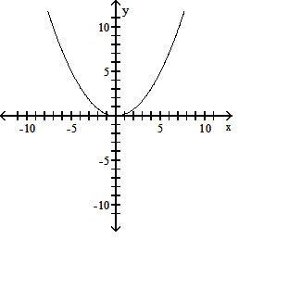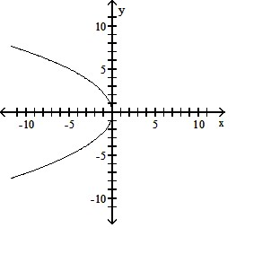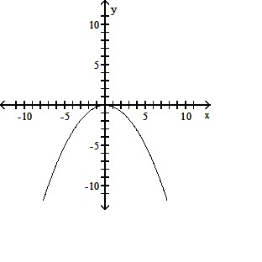
D) E) None of these
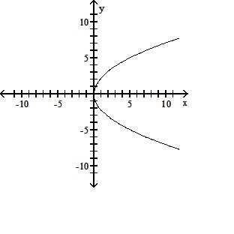

2.) Match the given equation with one of the graphs. $2x^{2}+4y^{2}-24x+24y+100=0$

A) B) C) 2.) _______
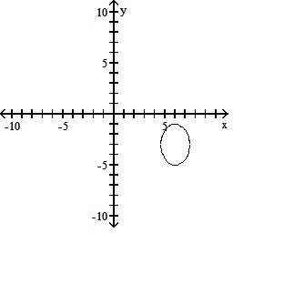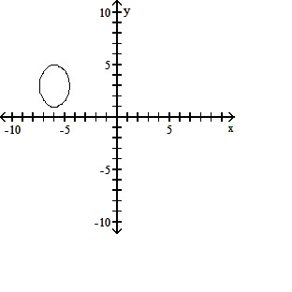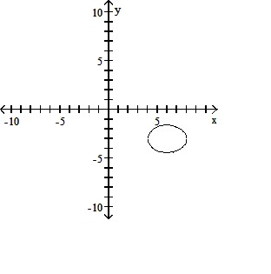
D) E) None of the above
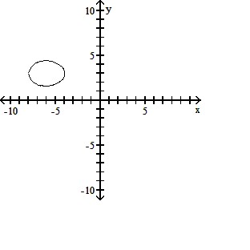

3.) Find the asymptotes of the hyperbola. $\frac{y^{2}}{400}-\frac{x^{2}}{225}=1$
3.) _______

A) y = $\frac{3}{4}$x, y = - $\frac{3}{4}$x B) y = $\frac{4}{3}$x + 1, y = - $\frac{4}{3}$x + 1 C) y = $\frac{4}{3}$x, y = - $\frac{4}{3}$x
D) y = $\frac{3}{4}$x + 1, y = - $\frac{3}{4}$x + 1 E) None of the above

4.) Match the given equation with one of the graphs.$x^{2}+y^{2}+4x+4y=0$ 4.) _______

A) B) C)
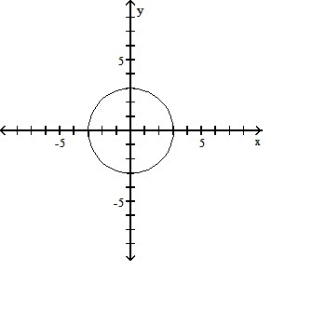
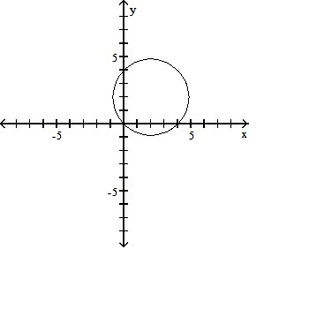 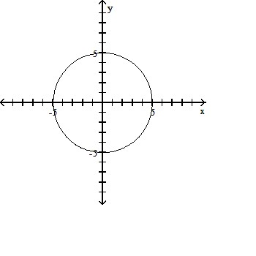D) E) None of the above
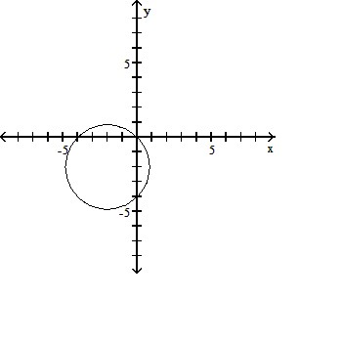
The following questions are each worth 6 points. Show your work.

5.) Find the focus and directrix of the parabola. $-\frac{1}{36}x^{2}=y$ 5.) ____________

6.) Find an equation of an ellipse satisfying the given conditions.
Foci at (0, -6), (0, 6); vertices at (0, -7), (0, 7) 6.) ____________

7.) Find the foci of the ellipse. $81x^{2}+y^{2}-324x+243=0$ 7.) ____________

8.) A field microphone used at a football game has a parabolic cross section and is 18 in. deep. The focus is 4 in. from the vertex. Find the width of the microphone at the opening.
Round to whole number.

8.) ____________

